8255

Intel 8255, the programmable peripheral interface interfaces. The peripheral components to the system bus for parallel data transfer. This chip is widely used as programmable parallel I/O device which can be programmed to transfer the data under various conditions to simple I/O to interrupt I/O. It has three 8 bit ports. Port A, port B and port C.8 bits of port C is grouped in two 4 bit ports represented as C_{upper} & C_{lower} .The 8255 functionally can be broadly programmed into 2 modes: Bit Set (BSR) mode and I/O mode. BSR mode is mainly used to set or reset the individual bits of port C whereas I/O mode is further divided into three modes: mode 0, mode 1 & mode 2.

Mode 0 is basic I/O mode, i.e.; in this mode port A, port B, port C_{upper} & port C_{lower} can be configured either as an Input port or an output port.

Mode 1 is a handshaking mode. In this mode 8255 is considered to be configured into 2 groups, i.e., group A and group B. Group A consists of 8 bit port A and 4 bit port C_{upper} .
Whereas group B consists of 8 bit port B and 4 bit port C_{lower} .In any of the 2 groups 8 bit ports can be programmed for I/O unidirectional operational by using 4 bit port for handshaking signals.

Mode 2 allows the bidirectional data transfer over a single 8 bit data bus using hand shaking signals. In this mode port A can be setup for bidirectional data transfer using handshaking signals from port C and port B can be setup either to mode O or mode 1.

The functional block diagram of 8255 is shown below

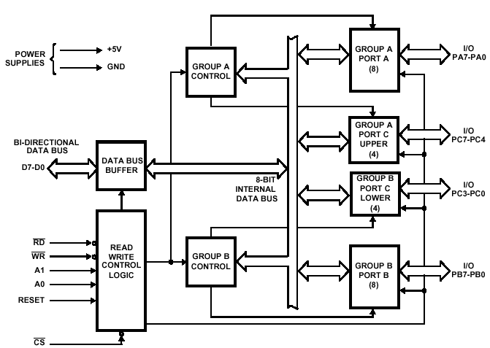

Block diagram of 8255

It has mainly three sections

1. Read/write control logic.
2. Data bus buffer.
3. Group A and group B controls.

Data Bus Buffer
This three-state bi-directional 8-bit buffer is used to interface the 8255 to the system data bus. Data is transmitted or received by the buffer upon execution of input or output instructions by the CPU. Control words and status information are also transferred through the data bus buffer.
Read/Write and Control Logic
The function of this block is to manage all of the internal and external transfers of both Data and Control or Status words. It accepts inputs from the CPU Address and Control busses and in turn, issues commands to both of the Control Groups.
(CS) Chip Select. A "low" on this input pin enables the communication between the 8255 and the CPU.
(RD) Read. A "low" on this input pin enables 8255 to send the data or status information to the CPU on the data bus. In essence, it allows the CPU to "read from" the 8255.
(WR) Write. A "low" on this input pin enables the CPU to write data or control words into the 8255.
(A0 and A1) Port Select 0 and Port Select 1. These input signals, in conjunction with the RD and WR inputs, control the selection of one of the three ports or the control word register. They are normally connected to the least significant bits of the address bus (A0 and A1).
(RESET) Reset. A "high" on this input initializes the control register to 9Bh and all ports (A, B, C) are set to the input mode.

A1 | A0 | SELECTION
0 | 0 | PORT A
0 | 1 | PORT B
1 | 0 | PORT C
1 | 1 | CONTROL
Group A and Group B Controls
The functional configuration of each port is programmed by the systems software. In essence, the CPU "outputs" a control word to the 8255. The control word contains information such as "mode", "bit set", "bit reset", etc., that initializes the functional configuration of the 8255. Each of the Control blocks (Group A and Group B) accepts "commands" from the Read/Write Control logic, receives "control words" from the internal data bus and issues the proper commands to its associated ports.
Ports A, B, and C
The 8255 contains three 8-bit ports (A, B, and C). All can be configured to a wide variety of functional characteristics by the system software but each has its own special features or "personality" to further enhance the power and flexibility of the 8255.
Port A One 8-bit data output latch/buffer and one 8-bit data input latch. Both "pull-up" and "pull-down" bus-hold devices are present on Port A.
Port B One 8-bit data input/output latch/buffer and one 8-bit data input buffer.
Port C One 8-bit data output latch/buffer and one 8-bit data input buffer (no latch for input). This port can be divided into two 4-bit ports under the mode control. Each 4-bit port contains a 4-bit latch and it can be used for the control signal output and status signal inputs in conjunction with ports A and B.
peripheral interface

All the functions of 8255 are classified according to two modes namely

- the bit set/reset (BSR) mode.
- The I/O mode.

The BSR Mode is used to set or reset the bits in port C. The I/O mode is further classified into three modes

- mode 0
- Mode 1 and
- Mode 2

- In mode 0 all ports function as simple I/O ports.

- Mode 1 is a handshake mode whereby port A and/or port B use bits from port C as handshake signals. In this mode two types of I/O data transfer can be implemented: status check and interrupt.

- In mode 2 port A can be set up for bidirectional data transfer using handshake signals from port C and port B can be set up either in mode 0 or mode 1.

BSR (bit set/reset) mode

the BSR mode is concerned only with the eight bits of port C, which can be set or reset by writing an appropriate control word in the control register. A control word with bit D7=0 is recognized as a BSR control word and it does not alter any previously transmitted control word with bit D7=1. Thus, the I/O operations of ports A and B are not affected by a BSR control word.

mode 0: simple output or input

In this mode, ports A and B are used as two simple 8-bit I/O ports and port C as two 4 bit ports Each port can be programmed to function as simply an input port or an output port. The input/output features in mode 0 are as follows:

- Outputs are latched.
- Inputs are not latched.
- Ports do not have handshake or interrupt capability.

mode 1: input or output with handshake

In mode 1 handshake signals are exchanged between the MPU and peripherals prior to data transfer. The features of this mode are

- Two ports (A and B) function as 8-bit I/O ports .they can be configured either as input port or as output ports.
- Each port uses three lines from port C as handshake signals the remaining two lines of port C can be used for simple I/O functions.
- Input and output data are latched.
- Interrupt logic is not supported.

in 8255 the specific lines from port C used for handshake signals vary according to the I/O function of a port.

mode 2: bidirectional data transfer

This mode is used primarily in applications such as data transfer between two computers or floppy disk controller interface. In this mode port A can be configured as the bidirectional port and port B either in mode 0 or in mode 1.

Port A uses five signals from port C as handshake signals for data transfer. The remaining three signals from port C can be used either as simple I/O or as handshake for port B.

Control word

8255 contains a 8-bit control register and contents of this register are called the control word, which specify an I/O function for each port. This register can be accessed to write a control word when A₀ and A₁ are at logic 1. The register is not accessible for a read operation.

Control word for I/O mode operation

bit | function
D7 | D7=1 MEANS I/O MODE  D7=0 MEANS BSR MODE
D6 D5 | D6 D5=0 0 MEANS MOD 0  D6 D5=0 1 MEANS MOD 1  D6 D5=1 x MEANS MOD 2
D4 | CONTROLS PORT A  D4=1 MEANS INPUT OPERATION  D4=0 MEANS OUTPUT OPERATION
D3 | CONTROLS PORT C UPPER  D3=1 MEANS INPUT OPERATION  D3=0 MEANS OUTPUT OPERATION
D2 | D2=0 MEANS MOD 0  D2=1 MEANS MOD 1
D1 | CONTROLS PORT B  D1=0 MEANS OUTPUT OPERATION  D1=1 MEANS INPUT OPERATION
D0 | CONTROLS PORT C LOWER  D0=0 MEANS OUTPUT OPERATION  D0=1 MEANS INPUT OPERATION

Control word for BSR mode operation

bit | function
D7 | FOR BSR MODE D7 SHOULD BE ZERO
D6 D5 D4 | NOT USED IN BSR MODE
D3 D2 D1 | USED TO SELECT THE BIT
D0 | USED TO SET OR RESET THE BIT

8251 UNIVERSAL SYNCHRONOUS ASYNCHRONOUS RECEIVER TRANSMITTER (USART)

The 8251 is a USART (Universal Synchronous Asynchronous Receiver Transmitter) for serial data communication. As a peripheral device of a microcomputer system, the 8251 receives parallel data from the CPU and transmits serial data after conversion. This device also receives serial data from the outside and transmits parallel data to the CPU after conversion.

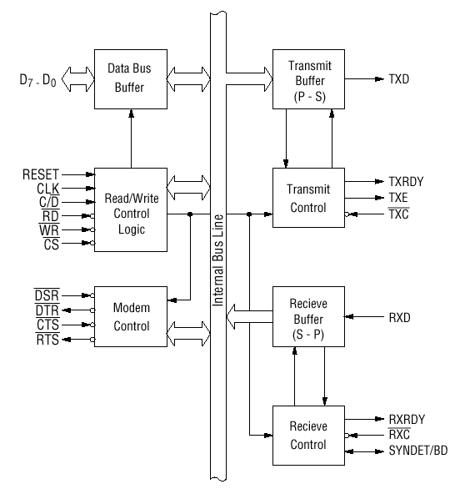
Block diagram of the 8251 USART (Universal Synchronous Asynchronous Receiver Transmitter)

The 8251 functional configuration is programmed by software. Operation between the 8251 and a CPU is executed by program control. Table 1 shows the operation between a CPU and the device.
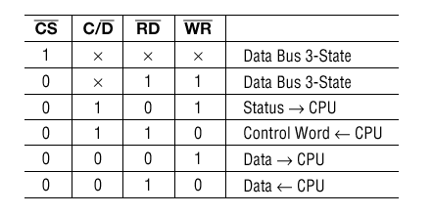
Table 1 Operation between a CPU and 8251

Control Words

There are two types of control word.
1. Mode instruction (setting of function)
2. Command (setting of operation)

  - Mode Instruction

Mode instruction is used for setting the function of the 8251. Mode instruction will be in "wait for write" at either internal reset or external reset. That is, the writing of a control word after resetting will be recognized as a "mode instruction."
Items set by mode instruction are as follows:
• Synchronous/asynchronous mode
• Stop bit length (asynchronous mode)
• Character length
• Parity bit
• Baud rate factor (asynchronous mode)
• Internal/external synchronization (synchronous mode)
• Number of synchronous characters (Synchronous mode)

The bit configuration of mode instruction is shown in Figures 2 and 3. In the case of synchronous mode, it is necessary to write one-or two byte sync characters. If sync characters were written, a function will be set because the writing of sync characters constitutes part of mode instruction.
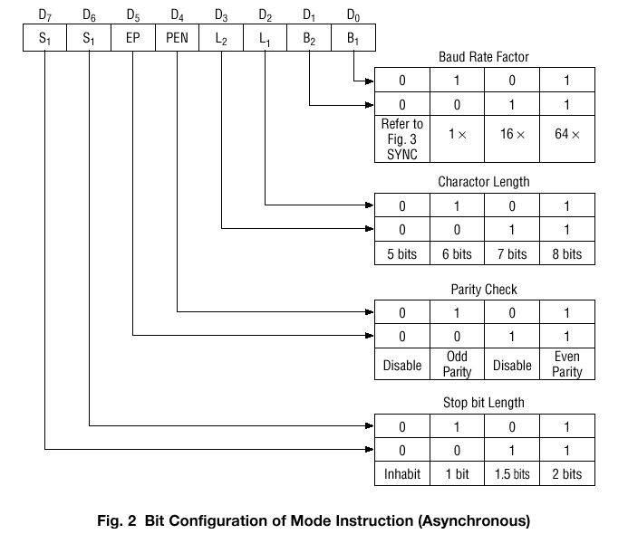

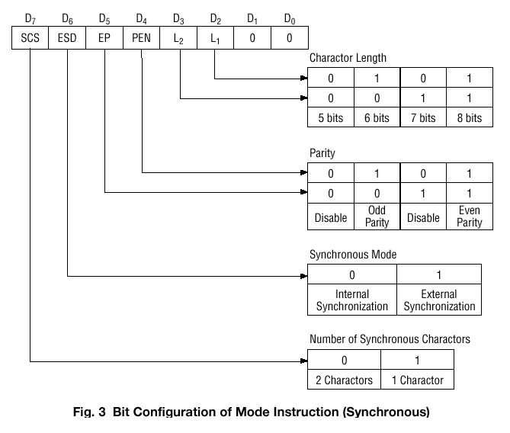

2) Command

Command is used for setting the operation of the 8251. It is possible to write a command whenever necessary after writing a mode instruction and sync characters.
Items to be set by command are as follows:
• Transmit Enable/Disable
• Receive Enable/Disable
• DTR, RTS Output of data.
• Resetting of error flag.
• Sending to break characters
• Internal resetting
• Hunt mode (synchronous mode)

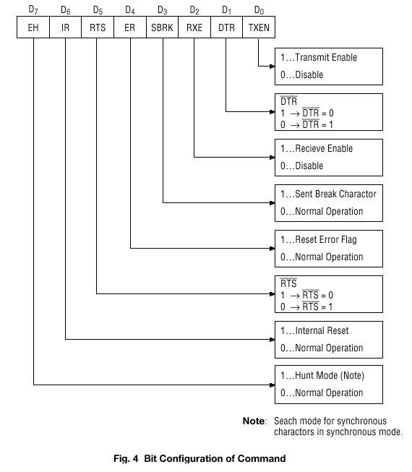

Status Word

It is possible to see the internal status of the 8251 by reading a status word. The bit configuration of status word is shown in Fig. 5.
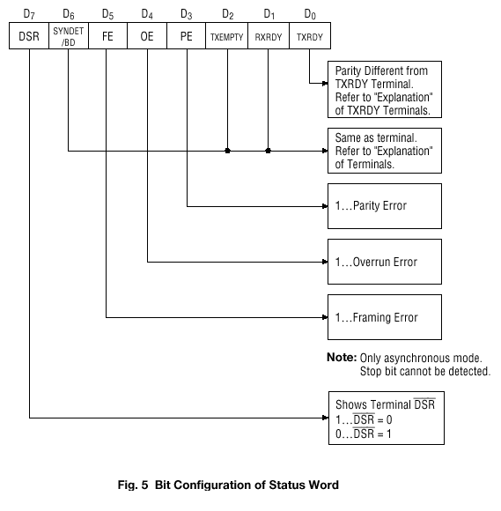

Pin Description

D 0 to D 7 (l/O terminal)

This is bidirectional data bus which receive control words and transmits data from the CPU and sends status words and received data to CPU.

RESET (Input terminal)

A "High" on this input forces the 8251 into "reset status." The device waits for the writing of "mode instruction." The min. reset width is six clock inputs during the operating status of CLK.

CLK (Input terminal)

CLK signal is used to generate internal device timing. CLK signal is independent of RXC or TXC. However, the frequency of CLK must be greater than 30 times the RXC and TXC at Synchronous mode and Asynchronous "x1" mode, and must be greater than 5 times at Asynchronous "x16" and "x64" mode.

WR (Input terminal)

This is the "active low" input terminal which receives a signal for writing transmit data and control words from the CPU into the 8251.

RD (Input terminal)

This is the "active low" input terminal which receives a signal for reading receive data and status words from the 8251.

C/D (Input terminal)

This is an input terminal which receives a signal for selecting data or command words and status words when the 8251 is accessed by the CPU. If C/D = low, data will be accessed. If C/D = high, command word or status word will be accessed.

CS (Input terminal)

This is the "active low" input terminal which selects the 8251 at low level when the CPU accesses. Note: The device won’t be in "standby status"; only setting CS = High.

TXD (output terminal)

This is an output terminal for transmitting data from which serial-converted data is sent out. The device is in "mark status" (high level) after resetting or during a status when transmit is disabled. It is also possible to set the device in "break status" (low level) by a command.

TXRDY (output terminal)

This is an output terminal which indicates that the 8251is ready to accept a transmitted data character. But the terminal is always at low level if CTS = high or the device was set in "TX disable status" by a command. Note: TXRDY status word indicates that transmit data character is receivable, regardless of CTS or command. If the CPU writes a data character, TXRDY will be reset by the leading edge or WR signal.

TXEMPTY (Output terminal)

This is an output terminal which indicates that the 8251 has transmitted all the characters and had no data character. In "synchronous mode," the terminal is at high level, if transmit data characters are no longer remaining and sync characters are automatically transmitted. If the CPU writes a data character, TXEMPTY will be reset by the leading edge of WR signal. Note : As the transmitter is disabled by setting CTS "High" or command, data written before disable will be sent out. Then TXD and TXEMPTY will be "High". Even if a data is written after disable, that data is not sent out and TXE will be "High".After the transmitter is enabled, it sent out. (Refer to Timing Chart of Transmitter Control and Flag Timing)

TXC (Input terminal)

This is a clock input signal which determines the transfer speed of transmitted data. In "synchronous mode," the baud rate will be the same as the frequency of TXC. In "asynchronous mode", it is possible to select the baud rate factor by mode instruction. It can be 1, 1/16 or 1/64 the TXC. The falling edge of TXC sifts the serial data out of the 8251.

RXD (input terminal)

This is a terminal which receives serial data.

RXRDY (Output terminal)

This is a terminal which indicates that the 8251 contains a character that is ready to READ. If the CPU reads a data character, RXRDY will be reset by the leading edge of RD signal. Unless the CPU reads a data character before the next one is received completely, the preceding data will be lost. In such a case, an overrun error flag status word will be set.

RXC (Input terminal)

This is a clock input signal which determines the transfer speed of received data. In "synchronous mode," the baud rate is the same as the frequency of RXC. In "asynchronous mode," it is possible to select the baud rate factor by mode instruction. It can be 1, 1/16, 1/64 the RXC.

SYNDET/BD (Input or output terminal)

This is a terminal whose function changes according to mode. In "internal synchronous mode." this terminal is at high level, if sync characters are received and synchronized. If a status word is read, the terminal will be reset. In "external synchronous mode, "this is an input terminal. A "High" on this input forces the 8251 to start receiving data characters.
In "asynchronous mode," this is an output terminal which generates "high level” output upon the detection of a "break" character if receiver data contains a "low-level" space between the stop bits of two continuous characters. The terminal will be reset, if RXD is at high level. After Reset is active, the terminal will be output at low level.

DSR (Input terminal)

This is an input port for MODEM interface. The input status of the terminal can be recognized by the CPU reading status words.

DTR (Output terminal)

This is an output port for MODEM interface. It is possible to set the status of DTR by a command.

CTS (Input terminal)

This is an input terminal for MODEM interface which is used for controlling a transmit circuit. The terminal controls data transmission if the device is set in "TX Enable" status by a command. Data is transmittable if the terminal is at low level.

RTS (Output terminal)

This is an output port for MODEM interface. It is possible to set the status RTS by a command.

8279

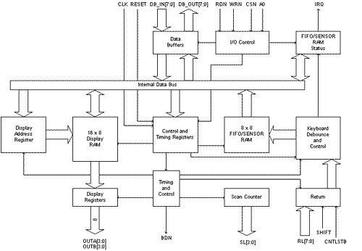

KEYBOARD SECTION

This section has eight lines (RL0-RL7) that can be connected to eight columns of a keyboard, plus two additional lines: Shift and CNTL/STB (Control/Strobe). The status of the SHIFT key and the Control key can be stored along with a key closure. The keys are automatically de-bounced, and the keyboard can operate in two modes: two-key lockout or N-key rollover. In the two-key lockout mode, simultaneous keys are recognized and their codes are stored in the internal buffer; it can also be set up so that no key is recognized until only one key remains pressed.
The keyboard section also includes 8*8 FIFO RAM. The FIFO RAM consists of 8 registers that can store 8 keyboard entries; each is then read in the order of entries. The statues logic keeps track of the number of entries and provides an IRQ (Interrupt Request) signal when the FIFO is not empty.

SCAN SECTION

The scan section has a scan counter and four scan lines (SL0-SL3). These four scan lines can be decoded using a 4-to-16 decoder to generate 16 lines for scanning. These lines can be connected to the rows of a matrix keyboard and the digit drivers of a multiplexed display.

DISPLAY SECTION

The display section has eight output lines divided into two groups A0-A3 and B0-B3. These lines can be used, either as a group of eight lines or as two groups of four, in conjunction with the scan lines for a multiplexed display. The display can be blanked by using the BD line. This section includes 16*8 displays RAM. The MPU can be read from or write into any of these registers.

MPU INTERFACE SECTION

This section includes 8 bidirectional data lines (DB0-DB7), one Interrupt line (IRQ), and 6 lines for interfacing, including the buffer address line (A0).
When A0 is high, signals are interpreted as control words or status; when A0 is low, signals are interpreted as data. The IRQ line goes high whenever data entries are stored in the FIFO. The signal is used to interrupt the MPU to indicate the availability of data.

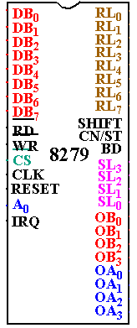

Pin out Definition 8279

- A0: Selects data (0) or control/status (1) for reads and writes between micro and 8279.
- BD: Output that blanks the displays.
- CLK: Used internally for timing. Max is 3 MHz.
- CN/ST: Control/strobe, connected to the control key on the keyboard.
- CS: Chip select that enables programming, reading the keyboard, etc.
- DB7-DB0: Consists of bidirectional pins that connect to data bus on micro.
- IRQ: Interrupt request, becomes 1 when a key is pressed, data is available.
- OUT A3-A0/B3-B0: Outputs that sends data to the most significant/least significant nibble of display.
- RD (WR): Connects to micro's IORC or RD signal, reads data/status registers.
- RESET: Connects to system RESET.
- RL7-RL0: Return lines are inputs used to sense key depression in the keyboard matrix.
- Shift: Shift connects to Shift key on keyboard.
- SL3-SL0: Scan line outputs scan both the keyboard and displays.

8252

The 8252 is a low-power; high-performance CMOS 8-bit microcomputer with8K bytes of downloadable Flash programmable and erasable read only memory and 2K bytes of EEPROM. The device is manufactured using Atmel’s high-density nonvolatile memory technology. It is compatible with the industry-standard 80C51 instruction set and pin out. The on-chip downloadable Flash allows the program memory to be reprogrammed in-system by a conventional nonvolatile memory programmer.

The 8252 provides the following standard features:

- 8K bytes of downloadable Flash.
- 2K bytes of EEPROM.
- 256 bytes of RAM.
- 32 I/O lines.
- Programmable watchdog timer,
- Two data pointers.
- Three 16-bit timer/counters.
- A six-vector two-level interrupt architecture.
- A full duplex serial port.
- On-chip oscillator
- Clock circuitry

8252 have three ports.

Port 0

Port 0 is an 8-bit open drain bi-directional I/O port.

Port 1

Port 1 is an 8-bit bi-directional I/O port.

Port 2

Port 2 is an 8-bit bi-directional I/O port. Port 2 emits the high-order address byte during fetches from external program memory and during accesses to external data memory that use 16-bit addresses. Port 2 also receives the high-order address bits and some control signals during Flash programming and verification.

Port 3

Port 3 is an 8 bit bi-directional I/O port. Port 3 also serves the functions of various special features. Port 3 receives some control signals for Flash programming and verification.

